Here's the **guitar chord chart** for *The House of the Rising Sun*:

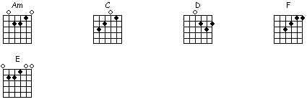

Here's the sheet music with **guitar tabs**:

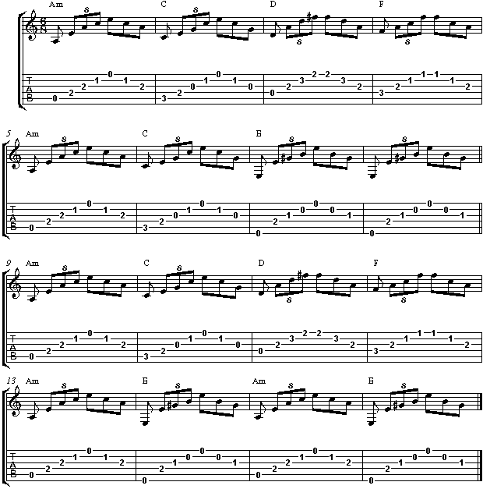

Here's the **easy version**, I simplified the finger picking to make it more playable for beginning guitarists:

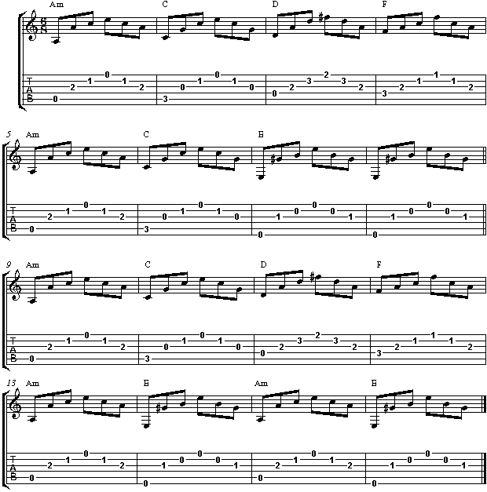

The **guitar chords and lyrics** for *House of the Rising Sun*:

# House of the Rising Sun – The Animals

Am         C        D            F  
There is a house in New Orleans   
  
     Am       C      E  
They call the Rising Sun   
  
         Am       C       D           F  
And it's been the ruin of many a poor boy   
  
    Am    E        Am   C     D     F     Am    E     Am    E  
And God I know I'm one   
  
  
   Am     C     D       F  
My mother was a tailor   
  
    Am       C        E  
She sewed my new blue jeans   
  
   Am     C     D        F  
My father was a gamblin' man   
  
Am      E     Am     C     D     F     Am    E     Am    E  
Down in New Orleans   
  
  
        Am   C       D       F  
Now the only thing a gambler needs   
  
     Am       C   E  
Is a suitcase and trunk   
  
        Am   C    D         F  
And the only time he's satisfied   
  
   Am        E    Am     C     D     F     Am    E     Am    E  
Is when he's on a drunk   
  
  
  
*** Organ Solo ***   
  
  
  
   Am     C         D           F  
Oh mother tell your children   
  
       Am      C      E  
Not to do what I have done   
  
Am         C        D       F  
Spend your lives in sin and misery  
  
       Am           E      Am     C     D     F     Am    E     Am    E  
In the House of the Rising Sun   
  
  
  
            Am       C      D           F  
Well, I got one foot on the platform  
  
    Am         C      E   
The other foot on the train   
  
    Am    C       D   F  
I'm goin' back to New Orleans   
  
   Am        E        Am     C     D     F     Am    E     Am    E  
To wear that ball and chain   
  
  
  
      Am         C        D     F  
Well, there is a house in New Orleans   
  
     Am       C      E  
They call the Rising Sun   
  
         Am       C       D           F  
And it's been the ruin of many a poor boy   
  
    Am    E        Am   C    D    F    Am    E    Am    F    Am    F...  
And God I know I'm one